Part 5 – Advanced Topics
2. Access-control & security: create two DB roles (analyst, guest) with different privileges and demonstrate them through failed/successful query screenshots; include short discussion of HIPAA/GLBA relevance to your dataset.
Getting everything sorted:
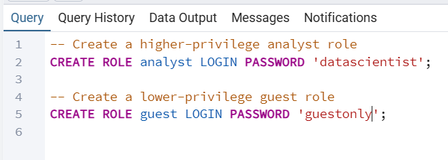
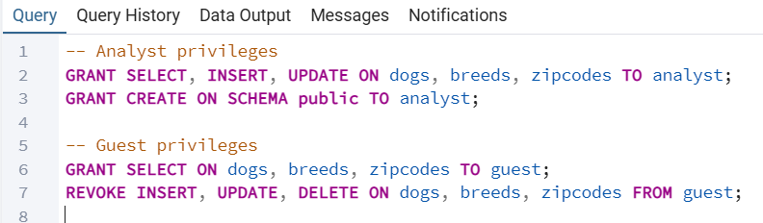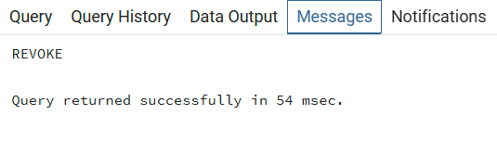
Connected as a guest:
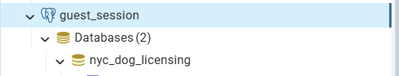
Guest can read:
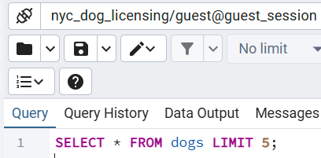
Output as:
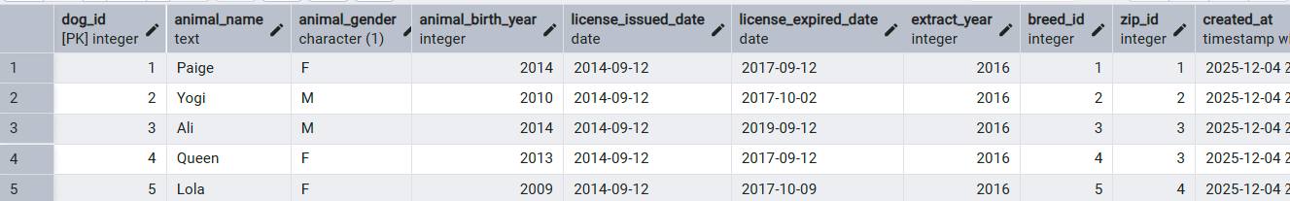
Guest cannot update:
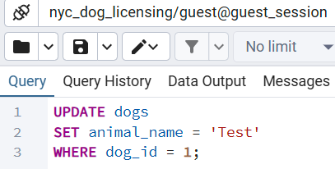
Failed update from guest shown below:
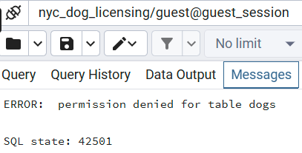
Now logged in as an analyst:
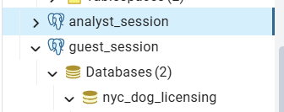
Analyst can write:
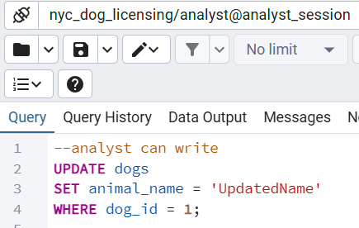
Proof of the result:
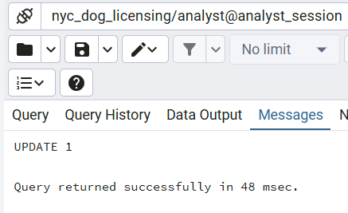

Part 2: Include short discussion of HIPAA/GLBA relevance to your dataset.
The NYC Dog Licensing dataset does not fall under HIPAA because there is no Protected Health Information (PHI) from a covered entity such as a hospital or insurer. It also does not fall under GLBA, which applies to financial institutions handling sensitive customer financial data. However, access-control best practices used in HIPAA and GLBA, such as least-privilege permissions, role separation, and preventing unauthorized modifications, are still relevant. Applying these principles ensures that potentially sensitive geographic or ownership-related data is handled responsibly, even if it is not legally regulated by HIPAA or GLBA. Zip codes are present in the dataset, and if any element of the dataset were combined with personal identifiers or medical or financial information about the owner or the animal, it could become sensitive and require stronger security controls.

